1. WebDriver is an interface.
2. Chromedriver.chromium.org/downloads—Till selenium 2 selenium guys were doing and from selenium3 google guys are taking care
3. Browser profiling: it means browser is launched by automation. It is duplicate of the original browser. It doesn’t have any history.
4. org.openqa.selenium.NoSuchSessionException: Session ID is null. Using WebDriver after calling quit()? If we you driver after driver.quit();

quit() will mak session id null.

1. org.openqa.selenium.NoSuchSessionException: invalid session id or seesion id is expired If we you driver after driver.close();

close() will not make session id null.

1. driver.get() – when the page is fully loaded then only execution will go to the next time. This is the property of the this method.
2. navigate().to()-- this method will not wait for the page to fully load and will go for next line execution.
3. WebElement Commands:

* clear()
* sendKeys()
* click()
* isDisplayed()
* isEnabled()
* isSelected()
* submit()
* getText()
* getTagName()
* getCssValue()
* getAttribute(String Name)

Ex: WebElement element = driver.findElement(By.id("SubmitButton"));

String attValue = element.getAttribute("id"); //This will return "SubmitButton"

* getSize()
  + Ex: WebElement element = driver.findElement(By.id("SubmitButton"));
  + Dimension dimensions = element.getSize();
  + System.out.println(“Height :” + dimensions.height + ”Width : "+ dimensions.width);
* getLocation():
  + Ex: WebElement element = driver.findElement(By.id("SubmitButton"));
  + Point point = element.getLocation();
  + System.out.println("X cordinate : " + point.x + "Y cordinate: " + point.y);

1. DropDownHandle:

* selectByIndex
* selectByValue
* selectByVisibleText
* isMultiple()—to check if it is multiselect
* getOptions()🡪List<WebElement>
* getFirstSelectedOption()
* getAllSelectedOptions()
* deselectAll()
* deselectByIndex()
* deselectByValue()
* deselectByVisibleText()

1. Actions.sendkeys() will move to that particular element and then perform the action but normal sendkeys() will just check for the locator and perform the action. It will not move to that element.

* Mouse Actions:

1. doubleClick()
2. clickAndHold()
3. dragAndDrop(src,target)
4. dragAndDrop(src,x,y)
5. moveByOddset(x,y)
6. moveToElement()
7. contextClick()
8. click()
9. release

* Keyboard Actions:

1. sendKeys()
2. keyUp()
3. keyDown()
4. Frames:

* switchTo.frame(int frameNumber): Pass the frame index and driver will switch to that frame.
* switchTo.frame(string frameNameOrId): Pass the frame element Name or ID and driver will switch to that frame.
* switchTo.frame(WebElement frameElement): Pass the frame web element and driver will switch to that frame.
* driver.switchTo().parentFrame();
* driver.switchTo().defaultContent();

1. Default value of any WebElement will be null;
2. Implicit wait:

* It will be applied for all the web elements and not on title
* global wait
* dynamic wait
* timeout is applied on driver after declaring implicitly wait
* Initially implicit wait is: driver.manage().timeouts().implicitlyWait(15,TimeUnit.SECONDS);

Update implicit wait:

driver.manage().timeouts().implicitlyWait(10,TimeUnit.SECONDS);

Make implicit wait null or zero:

driver.manage().timeouts().implicitlyWait(0,TimeUnit.SECONDS);

2 main reasons for not to use implicit wait.

* It is only applied for web elements, then what about the title and URL or browser property.
* It is global wait so unnecessary it will wait for every element, these are 2 major problems

1. Should not use implicitly and explicitly wait together
2. Explicit Wait: It can be applied to webelement ,title as well as URL. Basically, it can be applied to everything.
3. WebDriverWait

* Applied to specific element only. It is not a global wait.
* Will poll in ever 500 miliseconds
* Dynamic wait

1. Fluent wait

* a.timeout, b.polling period and c.ignoringException

* when to use: For handling ajax components
* Chrome:
* DesiredCapabilities capabilities = DesiredCapabilities.chrome();
* ChromeOptions options = new ChromeOptions();
* options.addArguments("incognito");
* capabilities.setCapability(ChromeOptions.CAPABILITY, options);
* FireFox:
* FirefoxProfile firefoxProfile = new FirefoxProfile();
* firefoxProfile.setPreference("browser.privatebrowsing.autostart", true);
* Internet Explorer:
* DesiredCapabilities capabilities = DesiredCapabilities.internetExplorer();
* capabilities.setCapability(InternetExplorerDriver.FORCE_CREATE_PROCESS, true);
* capabilities.setCapability(InternetExplorerDriver.IE_SWITCHES, "-private");

Exceptions:

1. IllegalStateException: If we don’t define the path for driver executables chromedriver.exe,geckodriver.exe and IEdriver.exe
2. org.openqa.selenium.WebDriverException: Timed out waiting for driver to start and subclass of Runtime Exception
3. org.openqa.selenium.WebDriverException: Access is denied. When I didn’t merge desired capabilities with chrome options
4. org.openqa.selenium.InvalidArgumentException: when user doesn’t enter https in the url this error comes
5. org.openqa.selenium.NoSuchSessionException: Session ID is null. Using WebDriver after calling quit()?
6. NoSuchElementException— When element is not found in IMPLICIT WAIT and normally also
7. TimeoutException: Expected condition failed: waiting for presence of element located by: By.id: username (tried for 3 second(s) with 500 milliseconds interval)—When explicit wait is used and element is not found in the given time
8. org.openqa.selenium.NoSuchWindowException: when target window is closed in between
9. org.openqa.selenium.ElementNotInteractableException: element not interactable
10. ElementClickInterceptedException: element click intercepted: Element is not clickable at point (60, 469). Other element would receive the click: <td class="Td__StyledTd-sc-17tmnn9-0 bxzuOD" data-onboarding="contact-name-cell" style="align-items: center; justify-content: center; padding: 0px; flex: 45 0 auto; width: 45px; max-width: 45px;">...</td>----------🡪element is present but it is not ckickable
11. org.openqa.selenium.WebDriverException: SafariDriver requires Safari 10 running on OSX El Capitan or greater.
12. StaleElementException:
13. TimeoutException: Thrown when a command does not complete in enough time. Thrown when element is not found in the given time.

JavaScriptExecutor:

1. document.querySelector("*[type='email']").getAttribute("id");

XPATH:

1. //htmltag[@prop1=’value’]

Ex: //input[@id=’username’]

Ex://*[@id=’username’]

Ex: //input[@class='form-control private-form__control login-email']

1. //htmltag[@prop1=’value’ and @prop2=’value’]

Ex: //input[@id=’username’ and @type=’email’]

Ex: //input[@id=’username’ and contains(@class,'form-control')]

Note: even more than 2 property can be given using the above syntax.

1. Contains() in xpath:

* //htmltag[contains(@prop,’value’)]
* **If id is dynamic like:**

<input id=’test_123’>

<input id=’test_232’>

<input id=’test_143’>

<input id=’test_153’>

* //input[contains(@id,’test_’)]
* //input[contains(@class,'login-email')]
* (//input[contains(@class,'form-control')])[1]

Or

(//input[contains(@class,'form-control')])[position()=1]

* (//input[contains(@class,'form-control')])[2]

Or

(//input[contains(@class,'form-control')])[position()=2]

* (//input[contains(@class,'form-control')])[last()] =>it goes to the last element of this xpath

1. text() in xpath:
   * Formula: //htmltag[text()=’value’]

Ex: //i18n-string[text()='Forgot my password']

Ex: //i18n-string[text()="Don't have an account?"]

Ex: //i18n-string[contains(text(),'have an account?')]

1. starts-with in xpath:

//htmltag[starts-with(@prop,’value’)]

Ex: //button[starts-with(@class,'uiButton')]/i18n-string

Ex: //img[starts-with(@class,'nav')]

Ex: //h1[starts-with(text(),'Sales')]

1. parent child:

//div//input -- indirect child

//div/input --direct child

**Xpath Axes:**

1. following xpath: all the followings

ex: //div[@class='input-group']//following::input[@name='username']

1. preceding xpath: all the precedings

ex: //input[@name='username']//preceding::div

1. preceding-sibling xapth:

Ex: //span[text()='test 0']//ancestor::td//preceding-sibling::td

Ex: //span[text()='test 0']//ancestor::td//preceding-sibling::td//input

OR

Ex: //span[text()='test 0']//ancestor::td//preceding-sibling::td//child::input

1. parent xpath: the parent

ex: //input[@name='username']//parent::div

1. child xpath: all children

ex: //div[@class='input-group']//child::input

1. Ancestor xpath: all ancestors

Ex : //div[@class='input-group']//ancestor::div

1. Self xpath:

Ex: //tbody[@class='Tbody-qo3zmn-0 kUrJrb']//span[text()='naveen k']//self::span

1. Descendant

Ex: //tbody[@class='Tbody-qo3zmn-0 kUrJrb']//descendant::td

**Reversing Xpath:** Traversing from child to parent -> grand parent -> super parent -> top parent in DOM

1. //input[@id=’username’]/../../..
2. //input[@id=’username’]//..//..//..

**CSS Selector:**

1. Id: #{id}

* #username
* input#username
* input[id=’username’]
* input[id=’username’][type=’email’]---css with 2 attribute

1. class: .{classname}

* .classname

Ex:- .form-control.private-form__control.login-email

* tagName.classname

Ex:- input.login-email

1. text:

* input[id^=’username’] ------------------starting text
* input[id$=’name’] -------------------ending text

1. contains:

* input[id*=’username’] -------------------contains

1. parent and child

* div>input[id=’username’]

1. Last child

* .Tr__StyledTr-sc-18z5uug-0.cjpBak.-odd > td:last-child

1. First child

* .Tbody-qo3zmn-0.kUrJrb > tr:first-child

1. Nth child

* .Tbody-qo3zmn-0.kUrJrb>tr:nth-child(3)

1. Comma Operator to Implement OR Operation

* **form#get-input,input#user-message**

1. first-of-type:

* **tree-branch>ul>li:first-of-type**

1. Last-of-type:

* **.tree-branch>ul>li:last-of-type**

1. nth of type:

* tr.Tr__StyledTr-sc-18z5uug-0.cjpBak.-odd:nth-of-type(3)

1. select all of type:

* ul#categories>li:nth-of-type(n)

1. Using ***sibling*** of element “+” Operator---**it is immediate next sibling**

* **li#mercedes + li**

1. You should use a **white space** between tags to locate the element. Use **“.” for class** and **“#” for id**.
2. Not operator in CSS to exclude

* Input.form-control.private-form_control:not(.login-password)

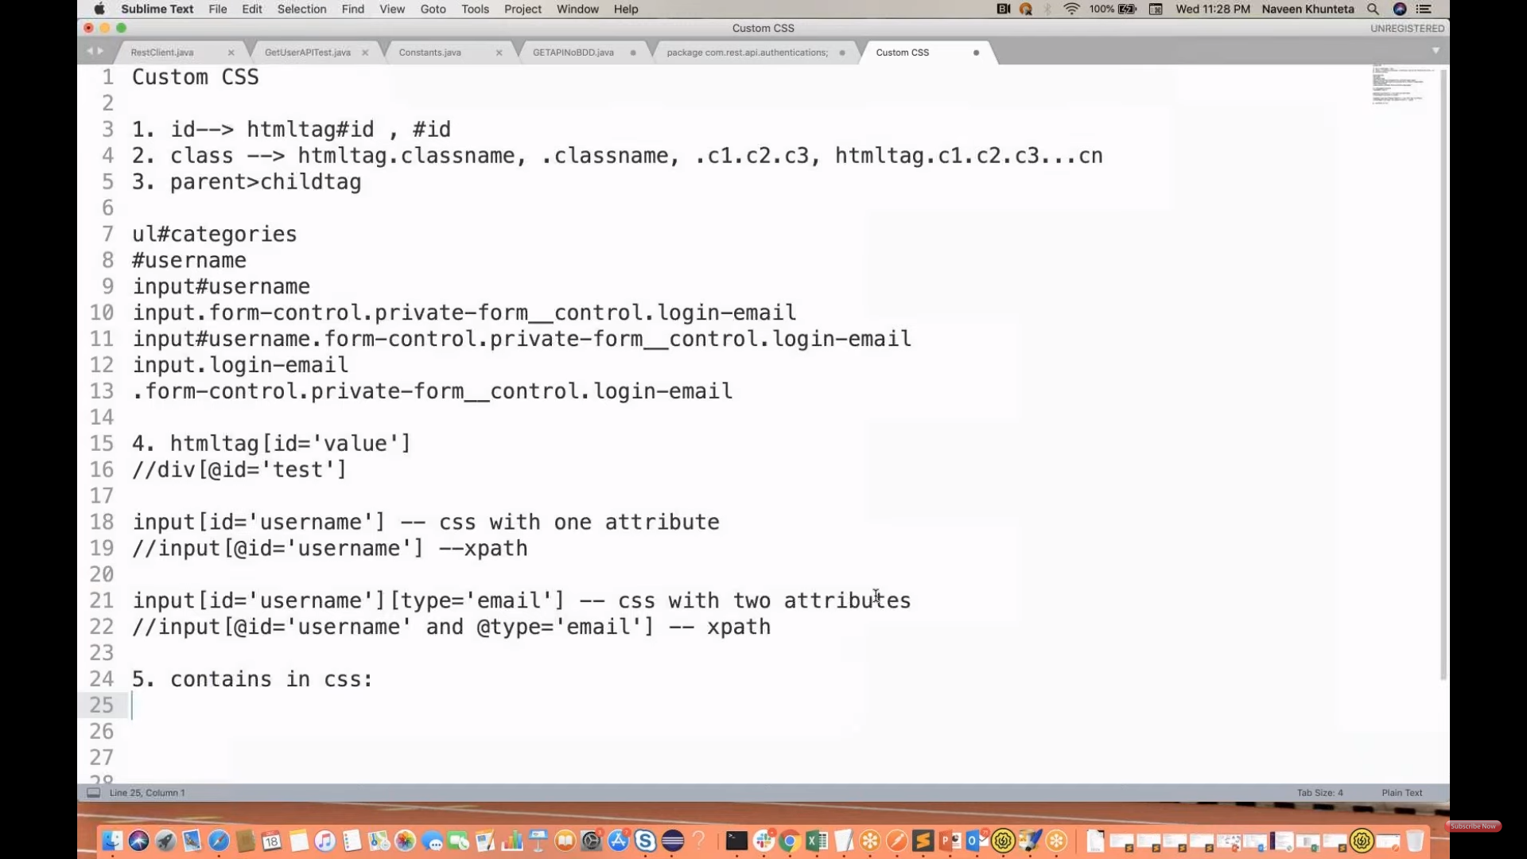

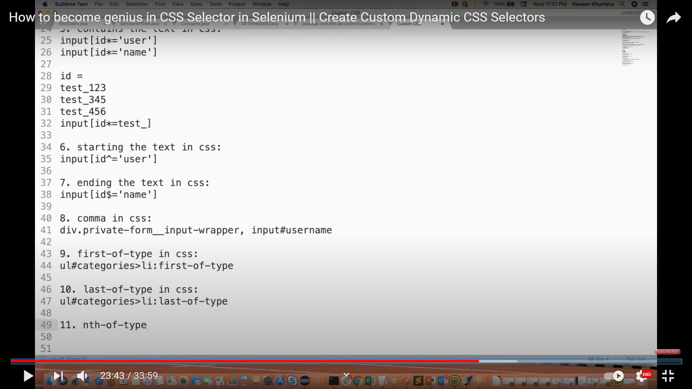

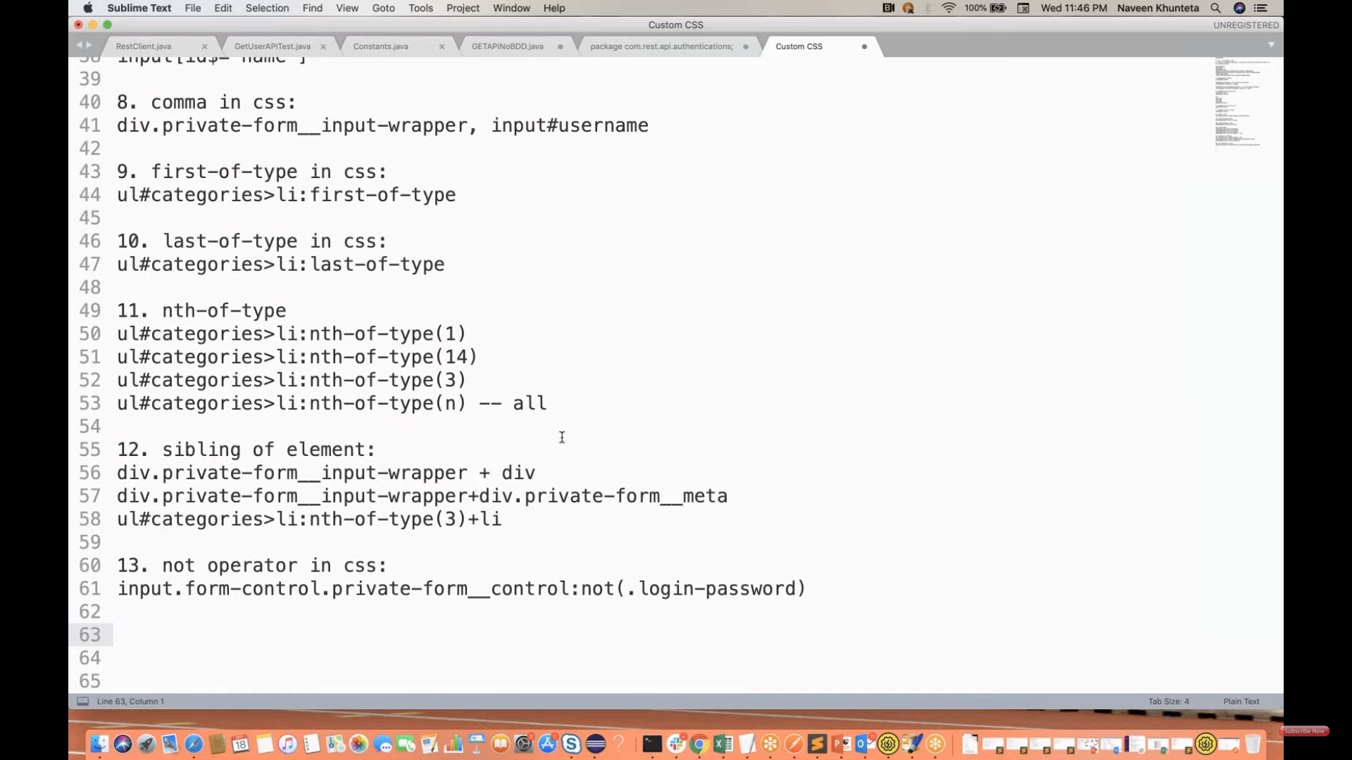

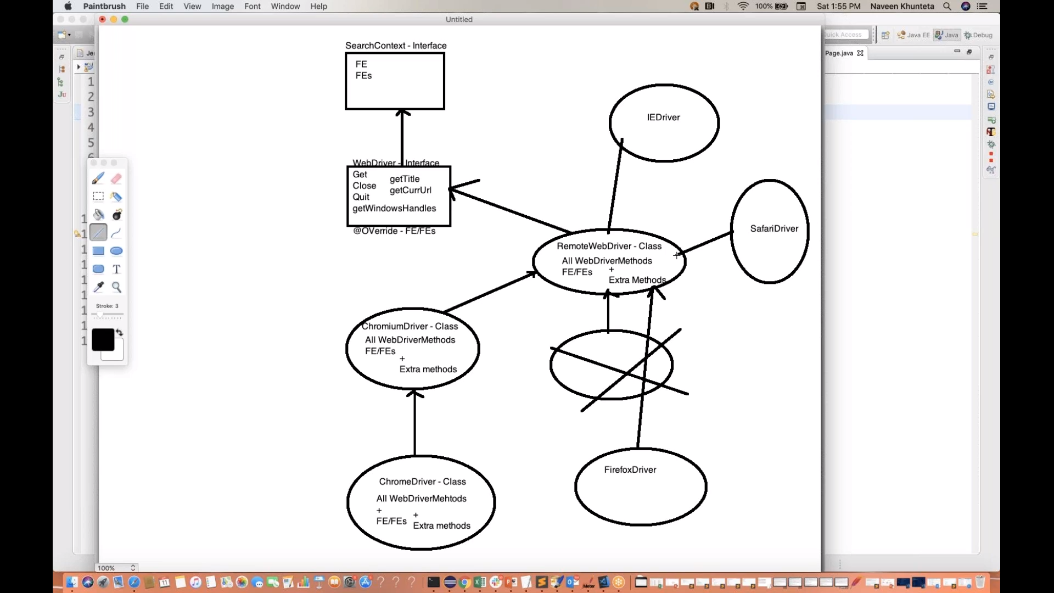

POM:

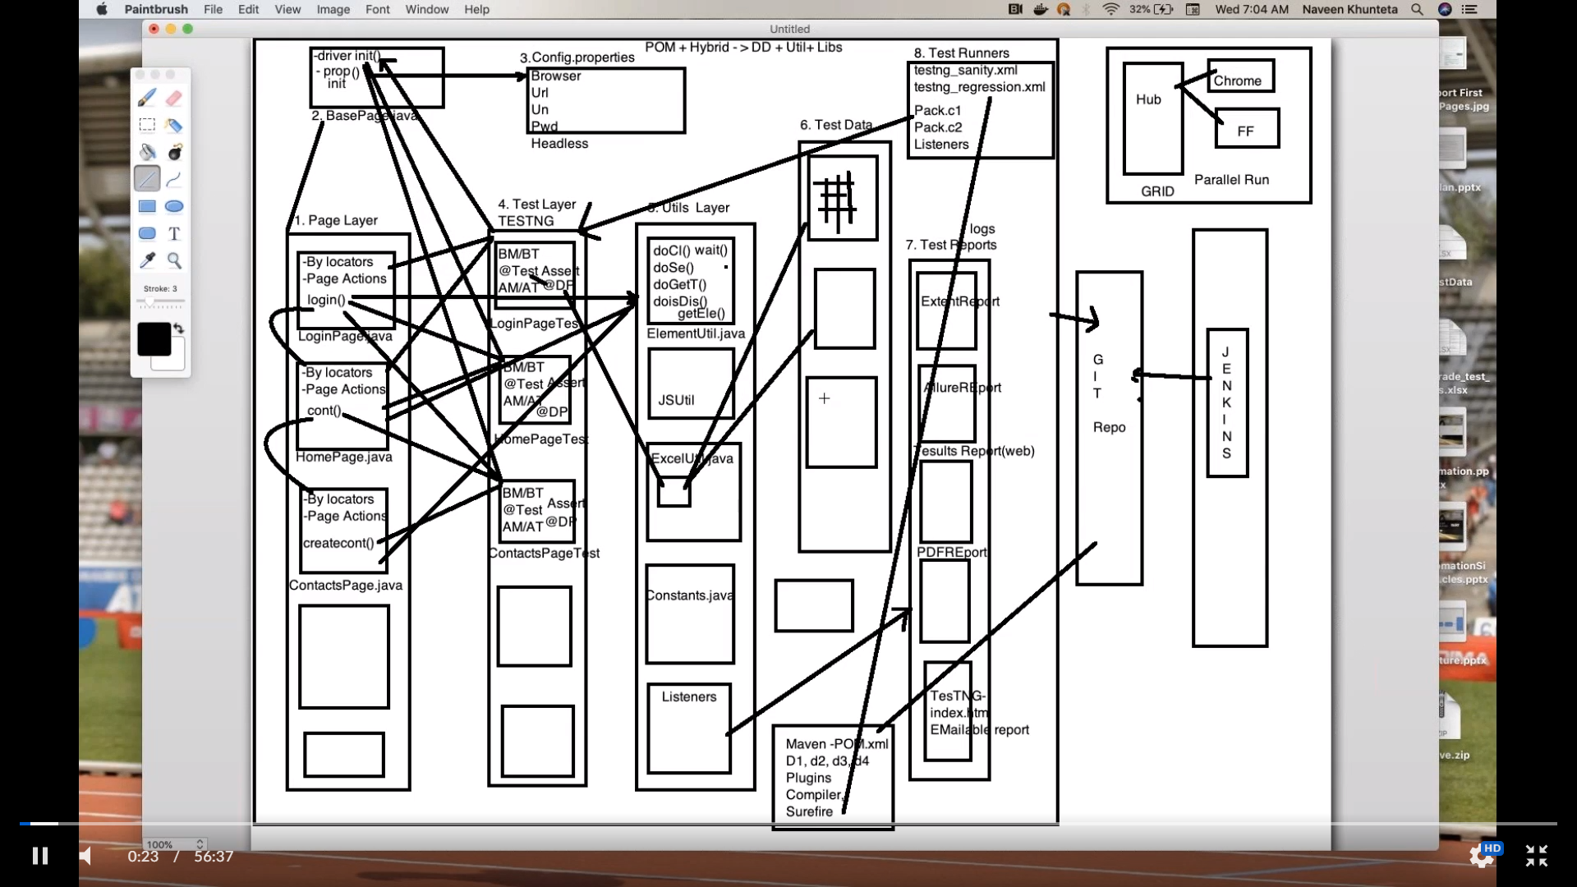

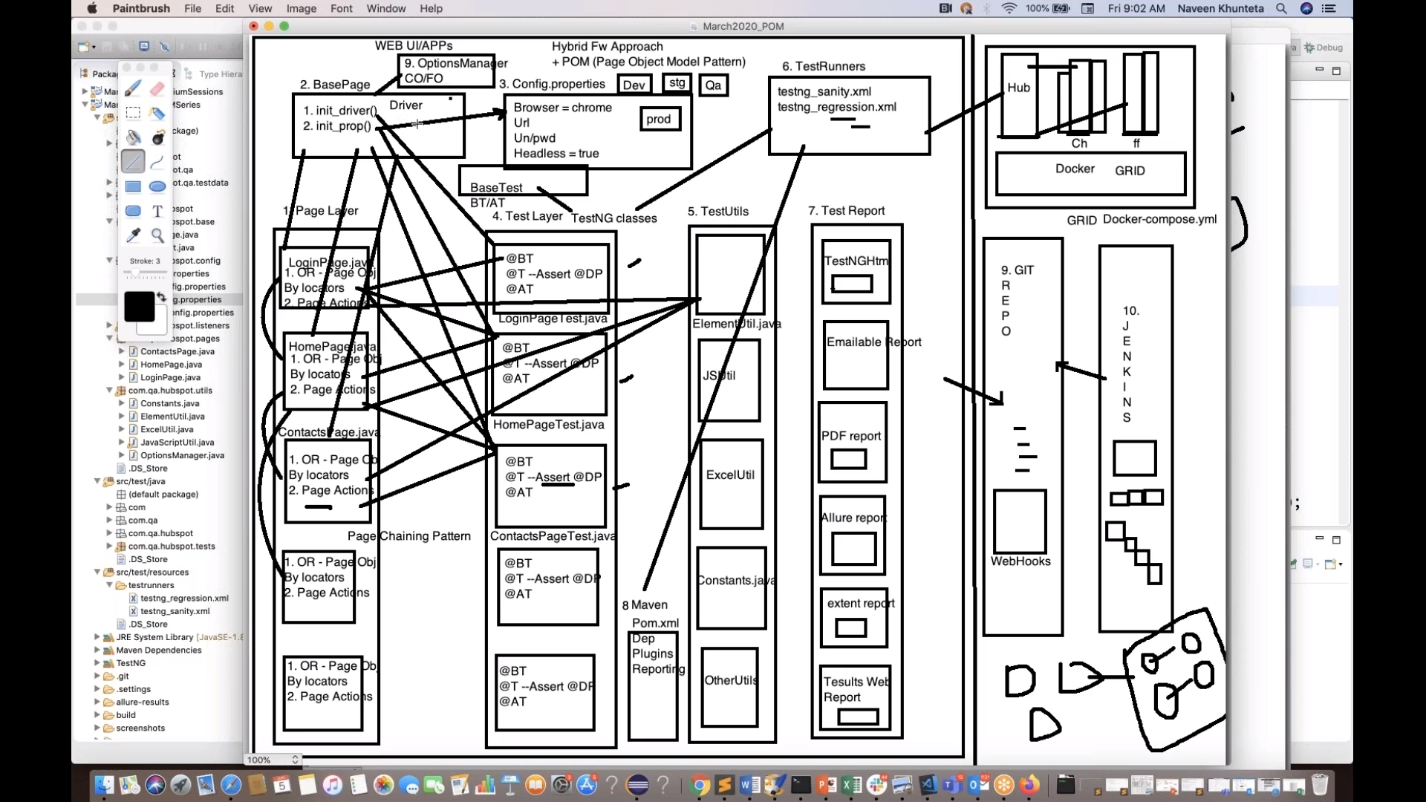

**HTML DOM:**

What is HTML DOM - Document Object Model? Why we get StaleElement Exception in Selenium.

• DOM is an API Interface provided by browser

• When a web page is loaded, browser creates a DOM of the page.

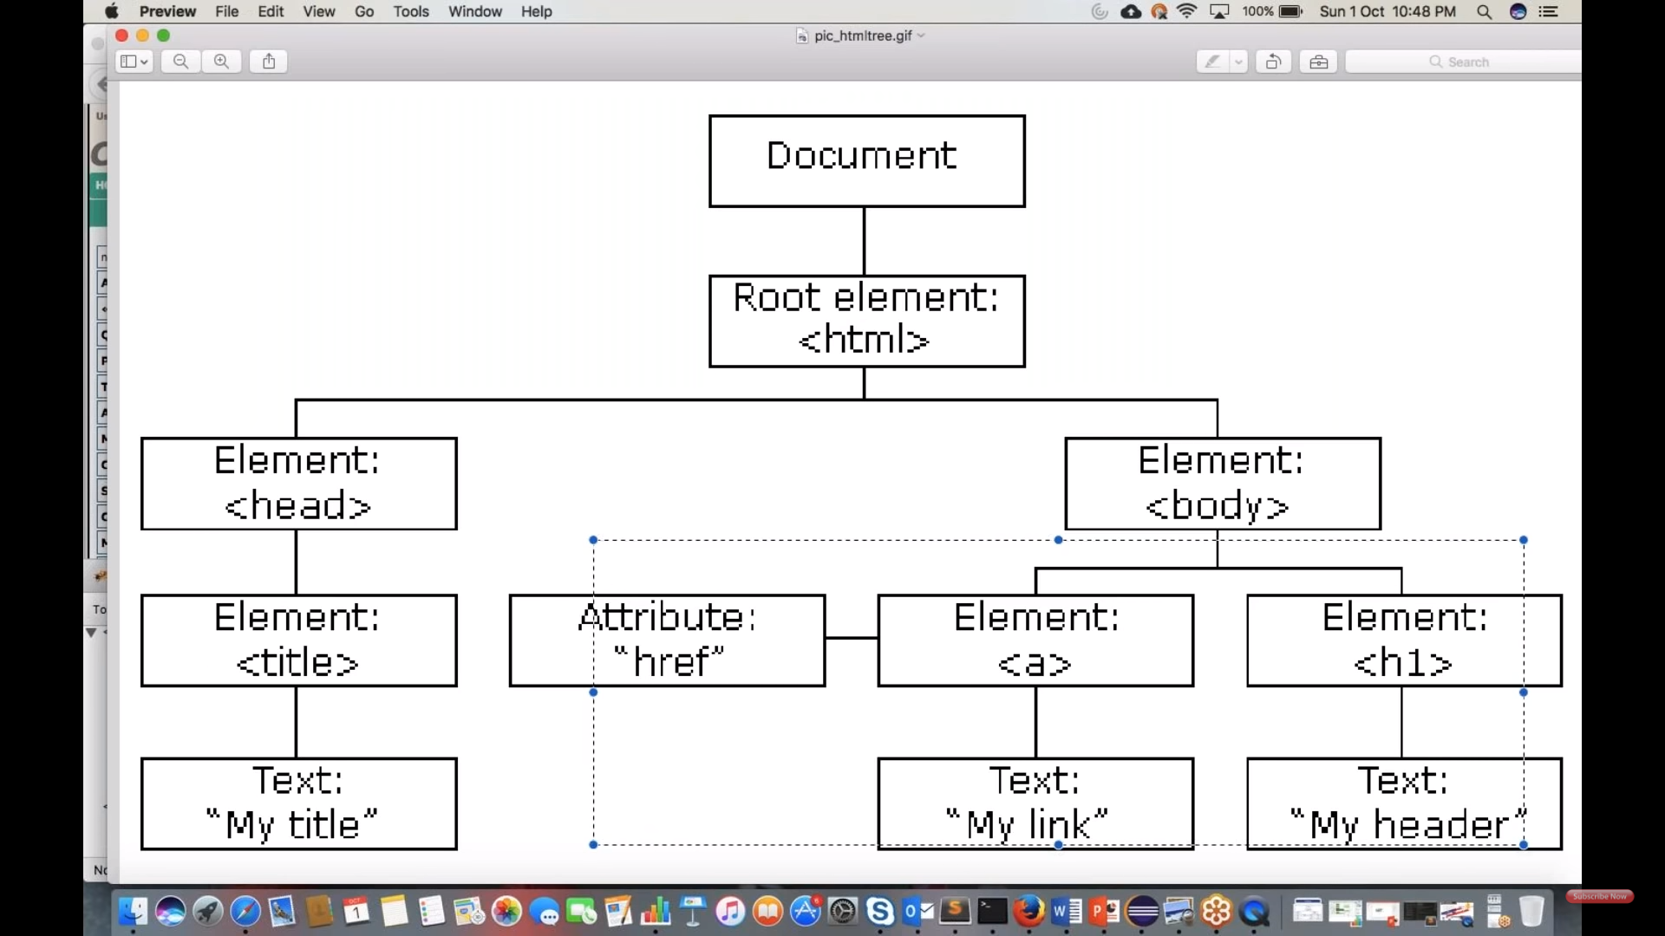=============================================

Learn What are the different Exceptions in Selenium:

a. StaleElement Exception

b. ElementNotFound Exception

c. NoElementReference Exception

=======================================

With the document object model, JavaScript gets all the power it needs to create dynamic HTML:

• JavaScript can change all the HTML elements in the page

• JavaScript can change all the HTML attributes in the page

• JavaScript can change all the CSS styles in the page

• JavaScript can remove existing HTML elements and attributes

• JavaScript can add new HTML elements and attributes

• JavaScript can react to all existing HTML events in the page

• JavaScript can create new HTML events in the page

SELENIUM GRID:

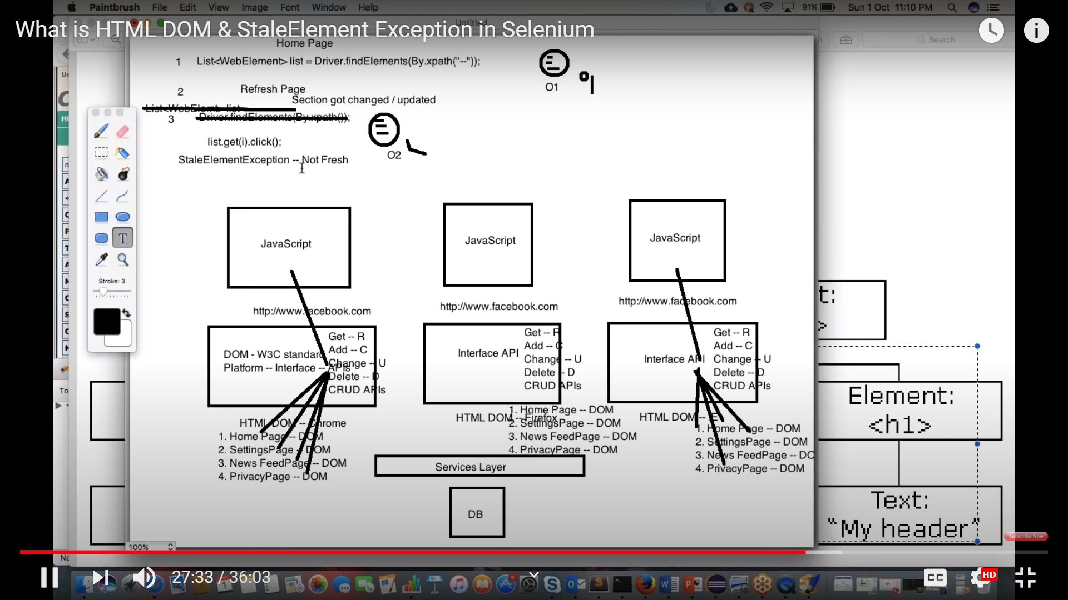

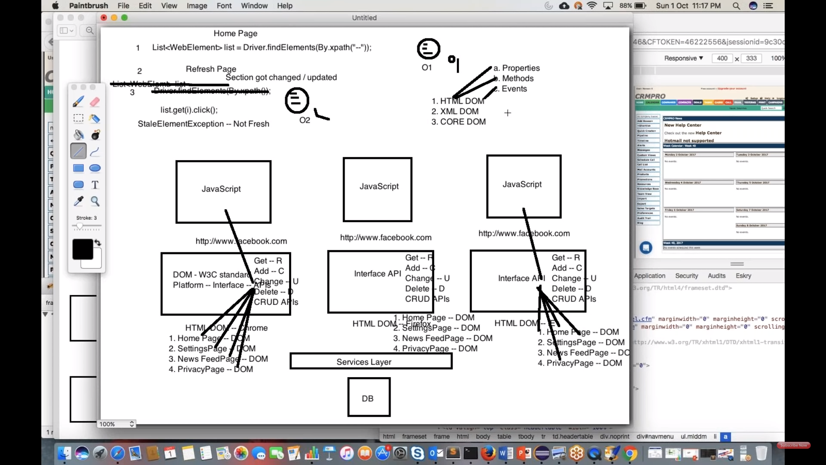

GIT:

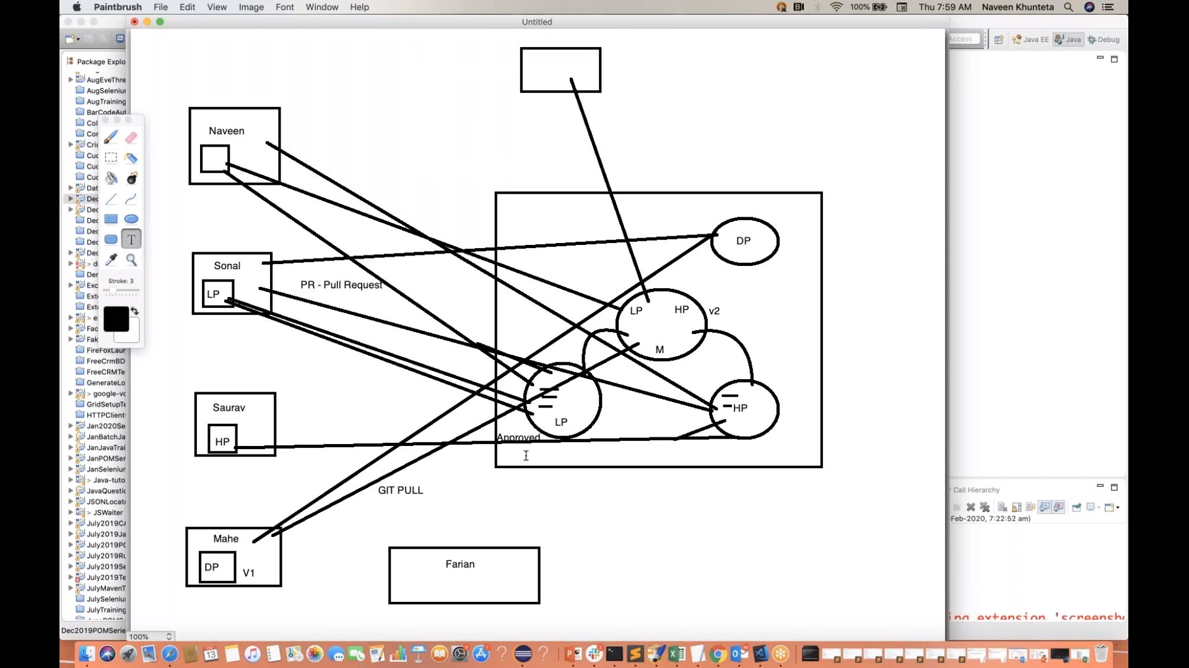

Inheritance:

We use base class in any framework which can be extended by all page classes and test classes.

In base class we write initialise WebDriver interface, WebDriver waits and to read property file and etc.

advantage is that we can avoid writing code to launch browser and as explain above in test classes.

Polymorphism:

It’s a combination of method overloading and method overriding.

Method overloading:

Implicit wait and handling frames are good examples of method overloading.

Here in implicit wait we can time in seconds, minutes, hours and so.

Method overriding:

We use Get() and navigate() methods which are already implement in another class that are changing it’s parameters

Abstraction: it is implemented using Abstract Class and inheritance.

Abstract class:

If your using POM design pattern in your framework.

All Pages classes are good examples of abstract class.

In Page classes we write and store all locators here and we make use of same locators in test classes which we cannot see them here.

Here we are hiding locators that we have defined in Page classes.

Interface:

Very basic statement we use in selenium is that WebDriver driver = new ChromeDriver.

Here WebDriver is an interface and ChromeDriver is a class.

As per above statement we are initialising ChromeDriver() Using WebDriver Interface.

Here we are creating a reference for WebDriver interface since we cannot create an object for interface.

Constructor:

If your approach is POM design pattern with help of PageFactory >> we define webelements using FindBy.

Here we use constructor to initialise webelements that are defined by using @FindBy.

Encapsulation:

We achieve encapsulation using all the classes that we use in our framework.

We define webelements using @FindBy and initialisation will be done by constructor to utilise them.

WebDriver Hierarchy:

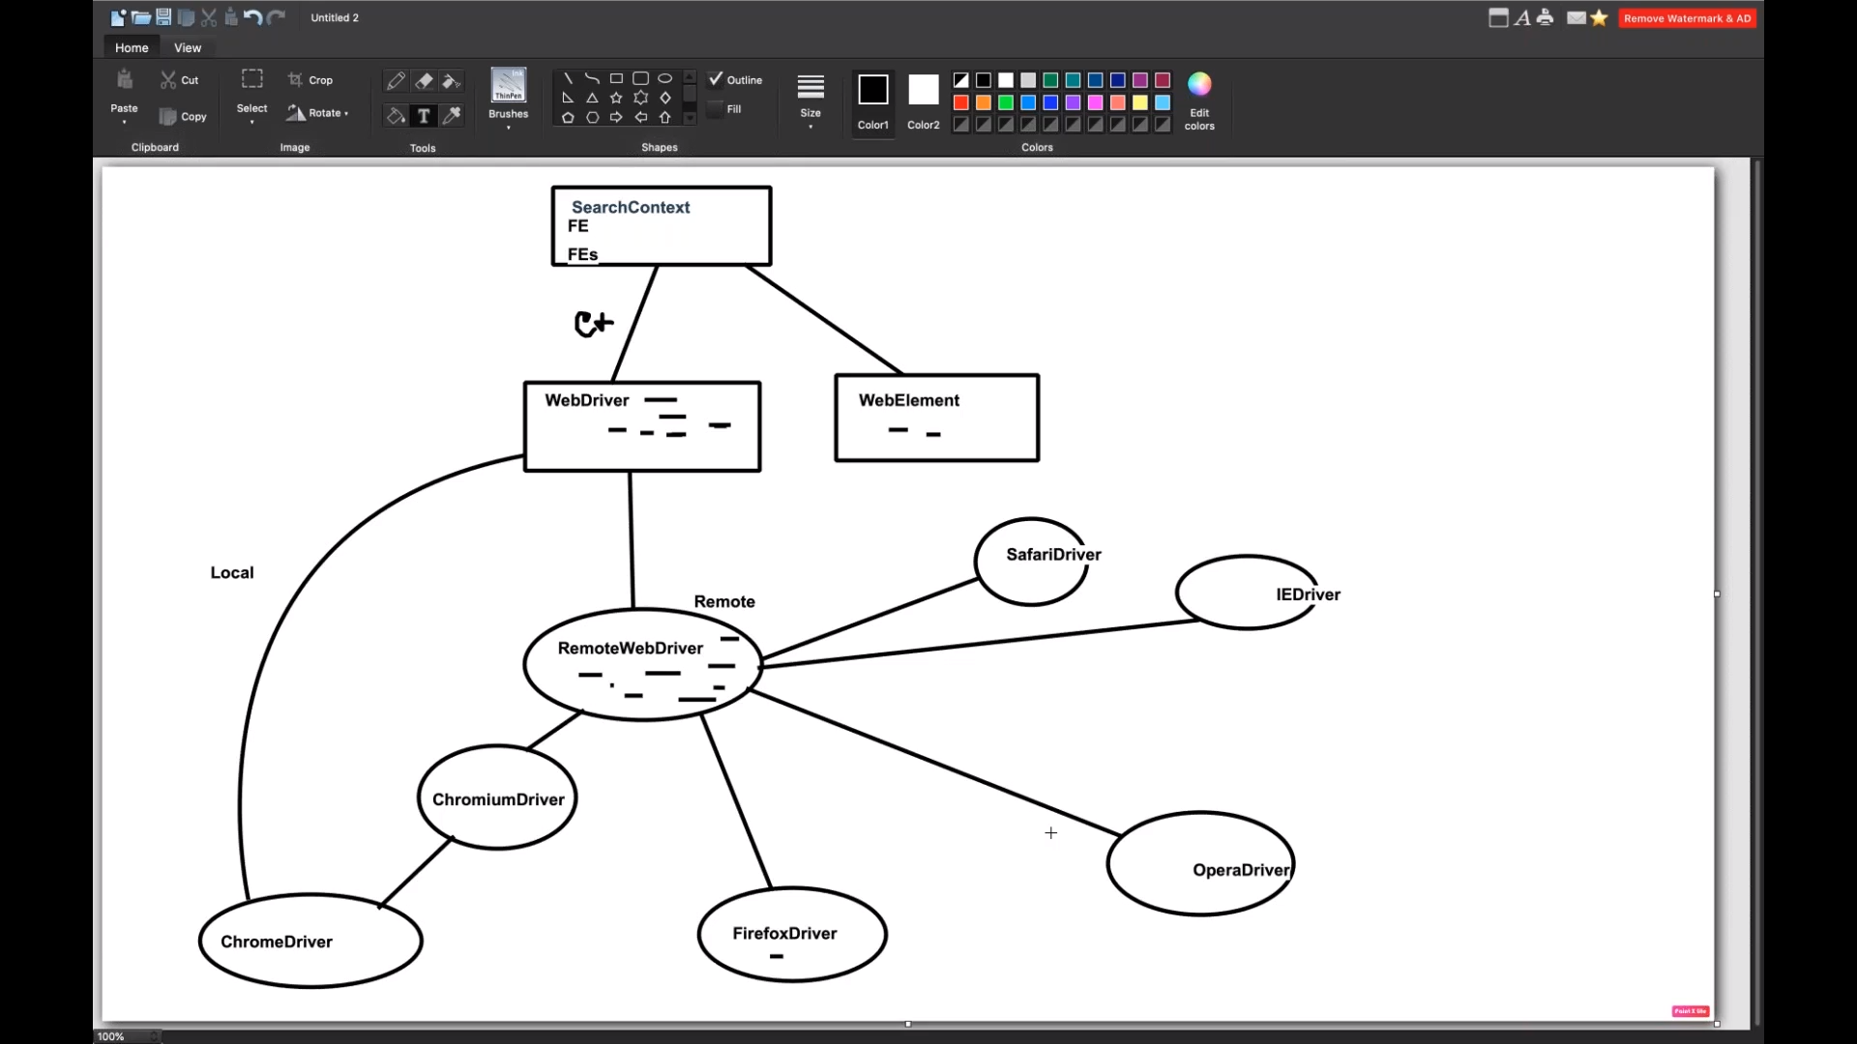

MultiThreading:

